SIMATS ENGINEERING (SAVEETHA SCHOOL OF ENGINEERING) Department of Computer Science and Engineering
ASSESSMENT TOOL 3 – Comparative Analysis
Course Code: | CSA06 | Course Title: | Design and Analysis of Algorithms
CO Assessed: | CO4: Articulation (BL4, BL5) | Assessment: | Assessment Tool 3 – Comparative Analysis
Weightage: | 10% of CIA | Total Marks: | 100
CO4 Statement: | Solve optimization problems using dynamic programming and greedy strategies.
Student Name: | P.Hemika | Reg. No.: | 192424259
Section / Batch: |  | Date:

Instructions to Students
• Answer the following question. Total Marks: 100.
• Analyze the given questions thoroughly before answering.
• Compare multiple aspects such as methods, results, advantages, and limitations clearly. • Critically evaluate the strengths, weaknesses, and implications with proper justification. • Present meaningful insights, interpretations, and well-supported conclusions from the comparisons.

Question Type | Focus Area | Questions
Comparative Analysis | Comparative analysis of Dynamic Programming and Greedy algorithms for optimization problems. | Q1

SECTION A – Comparative Analysis
Code of Conduct
I P.Hemika(192424259)certify that this submission is my original work and that I have adhered to the guidelines specified for this assessment. I understand that any violation of academic integrity rules will result in disciplinary action.
Signature of the Student: P.Hemika

Aim
To implement Word Wrap and Longest Palindromic Subsequence (LPS) using Dynamic Programming, compare their objective functions and recurrence relations, and analyze their computational complexity.

Algorithm
Word Wrap:
- Divide the given text into individual words.
- Calculate the extra spaces for placing consecutive words on each line.
- Use a DP table to find the minimum wrapping cost.
- Store the position of the previous word to reconstruct the optimal lines.
- Display the optimally wrapped text and minimum cost.
Longest Palindromic Subsequence:
- Take the given string as input.
- Create a DP table where dp[i][j] represents the LPS length from index i to j.
- Set dp[i][i] = 1.
- If the first and last characters match, add 2 to the inner subsequence.
- Otherwise, take the maximum of the two possible subsequences.
- Reconstruct and display the longest palindromic subsequence.

Program:

# Word Wrap vs Longest Palindromic Subsequence (DP Comparison)

# ---------------- INPUT ----------------
text = "This is a sample text for word wrapping"
width = 15

s = "character"

# ---------------- WORD WRAP ----------------
def word_wrap(words, width):
n = len(words)

# extra[i][j] = remaining spaces if words i to j are placed in one line
extra = [[0] * n for _ in range(n)]

for i in range(n):
extra[i][i] = width - len(words[i])
for j in range(i + 1, n):
extra[i][j] = extra[i][j - 1] - len(words[j]) - 1

# dp[i] = minimum cost for arranging first i words
dp = [float('inf')] * (n + 1)
parent = [-1] * (n + 1)

dp[0] = 0

for i in range(1, n + 1):
for j in range(i):
if extra[j][i - 1] >= 0:
# Last line is not penalized
if i == n:
cost = dp[j]
else:
cost = dp[j] + extra[j][i - 1] ** 2

if cost < dp[i]:
dp[i] = cost
parent[i] = j

# Reconstruct lines
lines = []
i = n

while i > 0:
j = parent[i]
line = " ".join(words[j:i])
lines.append(line)
i = j

lines.reverse()

return lines, dp[n]

# ---------------- LPS ----------------
def longest_palindromic_subsequence(s):
n = len(s)

if n == 0:
return "", 0

# dp[i][j] = length of LPS from i to j
dp = [[0] * n for _ in range(n)]

for i in range(n):
dp[i][i] = 1

# Fill table by increasing substring length
for length in range(2, n + 1):
for i in range(n - length + 1):
j = i + length - 1

if s[i] == s[j]:
if length == 2:
dp[i][j] = 2
else:
dp[i][j] = dp[i + 1][j - 1] + 2
else:
dp[i][j] = max(dp[i + 1][j], dp[i][j - 1])

# Reconstruct LPS
i = 0
j = n - 1
result = []

while i <= j:
if s[i] == s[j]:
result.append(s[i])
i += 1
j -= 1
elif dp[i + 1][j] >= dp[i][j - 1]:
i += 1
else:
j -= 1

left = "".join(result)
right = left[::-1]

if n % 2 == 1:
lps = left + right[1:]
else:
lps = left + right

return lps, dp[0][n - 1]

# ---------------- EXECUTION ----------------

words = text.split()

wrap_result, wrap_cost = word_wrap(words, width)
lps_result, lps_length = longest_palindromic_subsequence(s)

print("========== WORD WRAP ==========")
print("Input Text :", text)
print("Line Width :", width)
print("\nWrapped Text:")

for line in wrap_result:
print(line)

print("\nMinimum Word Wrap Cost:", wrap_cost)

print("\n========== LPS ==========")
print("Input String :", s)
print("Longest Palindromic Subsequence :", lps_result)
print("LPS Length :", lps_length)

print("\n========== COMPARATIVE ANALYSIS ==========")
print("Word Wrap Objective:")
print("Minimize the sum of squares of extra spaces in each line.")

print("\nWord Wrap Recurrence:")
print("dp[i] = min(dp[j] + extra[j][i-1]^2)")

print("\nLPS Objective:")
print("Maximize the length of the palindromic subsequence.")

print("\nLPS Recurrence:")
print("If s[i] == s[j]: dp[i][j] = dp[i+1][j-1] + 2")
print("Otherwise: dp[i][j] = max(dp[i+1][j], dp[i][j-1])")

print("\nComplexity:")
print("Word Wrap : O(n^2) time, O(n^2) space")
print("LPS : O(n^2) time, O(n^2) space")

print("\nConclusion:")
print("Both problems use Dynamic Programming by storing solutions")
print("to smaller subproblems. Word Wrap minimizes formatting cost,")
print("whereas LPS maximizes the length of a valid subsequence.")
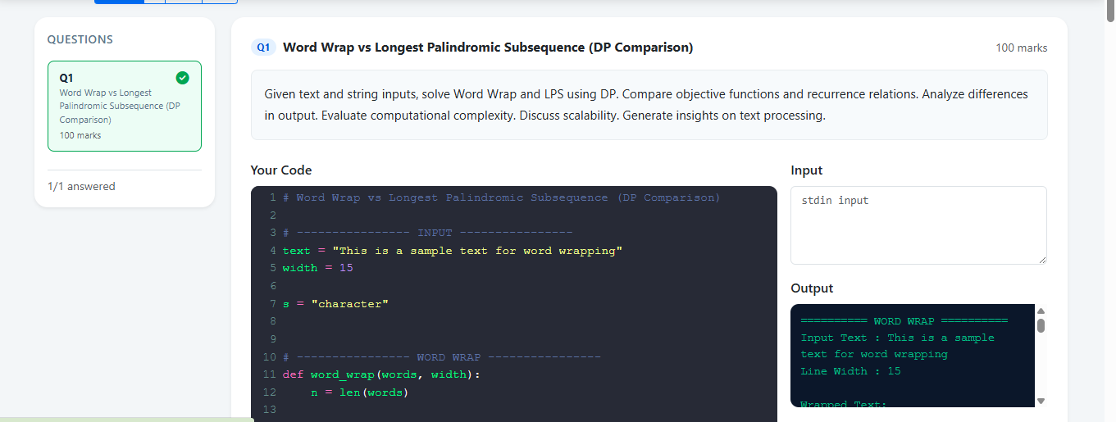
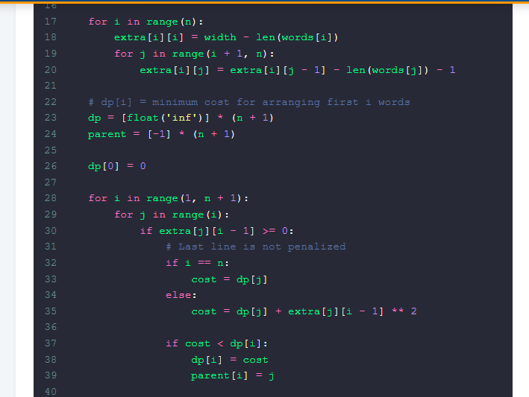
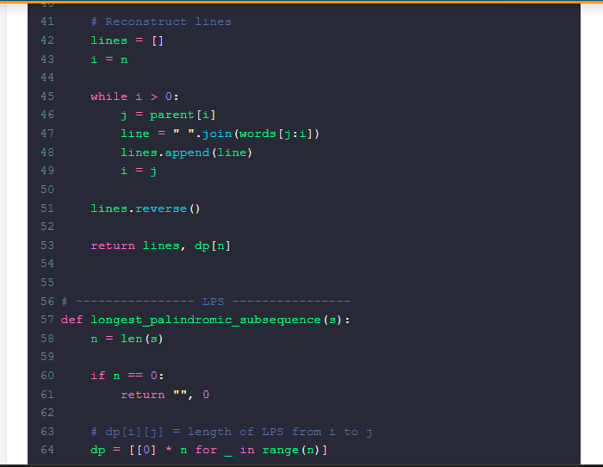

Result
The Word Wrap problem successfully minimizes the extra-space cost using Dynamic Programming, while the LPS problem successfully finds the longest palindromic subsequence. Both algorithms have O(n²) time and O(n²) space complexity, demonstrating the effectiveness of Dynamic Programming for optimization problems.

RUBRICS FOR CALCULATION
Comparative Analysis
Criteria | Weightage | Level 4 (Exemplary) | Level 3  (Proficient) | Level 2  (Developing) | Level 1  (Beginning)
Selection of  Studies/Parameters | 20% | Selects highly relevant and diverse studies with well-defined  comparison parameters | Selects relevant studies with minor gaps in parameter definition | Limited or  partially  relevant  selection | Poor or  inappropriate  selection of  studies
Comparison &  Differentiation | 25% | Clearly compares  multiple aspects  (methods, results,  limitations) with strong differentiation | Good comparison with minor gaps | Basic  comparison  with limited  depth | No clear  comparison;  mostly  descriptive
Critical Evaluation | 25% | Critically evaluates  strengths, weaknesses, and implications with strong justification | Provides  evaluation with  some justification | Limited  evaluation;  lacks depth | No critical  evaluation  provided
Synthesis & Insight Generation | 20% | Generates meaningful insights and conclusions from comparisons | Some insights  derived from  comparison | Limited or  unclear insights | No insights  generated
Clarity | 10% | Information is clearly presented  (tables/figures) with logical structure | Generally clear  with minor issues | Presentation  lacks clarity or structure | Poor  presentation and difficult to  understand

Marks Evaluation:
Criteria | Wt. | Level 4 –  Exemplary | Level 3 –  Proficient | Level 2 –  Developing | Level 1 –  Beginning
Selection of Studies/Parameters | 20%
Comparison & Differentiation | 25%
Critical Evaluation | 25%
Synthesis & Insight Generation | 20%
Clarity | 10%
Total Marks (100):

Faculty In-charge | Course Coordinator | Head of Department
Name: | Name: | Name:
Signature: _______________ | Signature: _______________ | Signature: _______________
Date: ___________________ | Date: ___________________ | Date: ___________________

